[](https://www.google.co.uk/url?sa=i&url=https%3A%2F%2Fwww.pinterest.com%2Fpin%2F853221091889966163%2F&psig=AOvVaw241psD_-XC5YkXNSDsJg2V&ust=1593690548333000&source=images&cd=vfe&ved=0CAIQjRxqFwoTCID_io3-q-oCFQAAAAAdAAAAABAD)[](https://www.google.co.uk/url?sa=i&url=http%3A%2F%2Fclipart-library.com%2Fclipart%2F11637.htm&psig=AOvVaw3EhkNSI60ngLd54cevn_sL&ust=1593690450366000&source=images&cd=vfe&ved=0CAIQjRxqFwoTCOiu3t_9q-oCFQAAAAAdAAAAABAD)[](https://www.google.co.uk/url?sa=i&url=http%3A%2F%2Fwww.freepngclipart.com%2Fcategory%2Fschool%2Fstack-of-books%2Fdate%2Fpage%2F3&psig=AOvVaw1JCtlknUDQVyAlOsmYkrkV&ust=1593690290698000&source=images&cd=vfe&ved=0CAIQjRxqFwoTCNjhnZP9q-oCFQAAAAAdAAAAABAS)[](https://www.google.co.uk/url?sa=i&url=https%3A%2F%2Fwebstockreview.net%2Fexplore%2Fplate-clipart-coloring-page%2F&psig=AOvVaw2Ug6OPsskGYzDlWcxH96o3&ust=1593690191964000&source=images&cd=vfe&ved=0CAIQjRxqFwoTCMiRiuL8q-oCFQAAAAAdAAAAABAD)[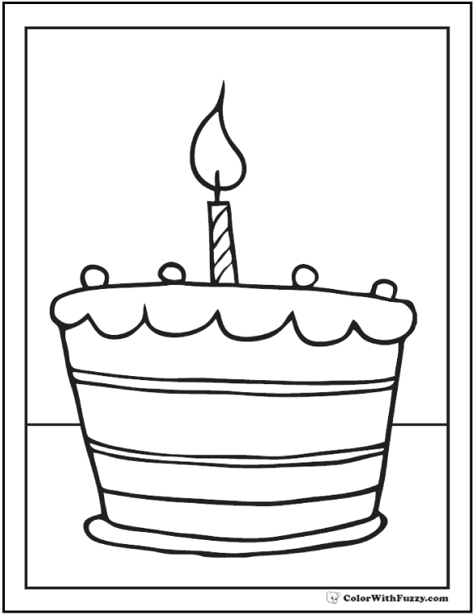](https://www.google.co.uk/url?sa=i&url=https%3A%2F%2Fwww.colorwithfuzzy.com%2Fbirthday-cake-coloring-page.html&psig=AOvVaw34UY1f80dvWP_Pua3llgT4&ust=1593689206387000&source=images&cd=vfe&ved=0CAIQjRxqFwoTCNjerZr5q-oCFQAAAAAdAAAAABAK)

**This is me…**

**My name is…**

**My favourite animal is…**

**Something that makes**

**me happy is…**

**My favourite colour is…**

**A funny joke I know is…**

**My favourite TV programme is…**

**When I am older I would like to be…**

**I like spending time with…**

**My favourite food is…**

**My favourite book is…**

**I like playing…**

**My birthday is…**