Welcome to Red Kite Class
2020-2021

Teacher: Miss Earrye
Teaching assistant: Mrs Wallace

It is important that I start to get to know all about you ready for when you start Year 6 in September.
Please complete the ‘figure me out’ activity and email to me: year6@thurstonprimary.net

The other activities in this booklet can be completed and brought back into school in September.
If you have any questions or worries about next year please email me at the above address.

I look forward to seeing you all soon.
Miss Earrye

Figure me out!

Create maths questions where the answers give key information about you. For example: your shoe size e.g. 16÷4
Please find an example below:
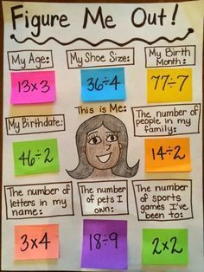
I have included a template on the next page but feel free to create your own. You can use post it notes to hide the answers!
Figure me out!

This is me…

Activity 1 - Ending the academic year can be a time that is full of mixed emotions for many children. However, whilst many aspects of school life change, many remain the same too. Spend some time discussing all of the similarities and differences between your current class and the new class that you will be going into. For example: cloakrooms will stay the same but you will have lockers… Create a table showing the similarities and differences.

Activity 2 - Art can be a great tool for self-exploration and self-expression. Create a piece of artwork which represents your personality and highlights your individual qualities. This could be a picture or something more abstract using materials available at home. What will I learn about your personality from your picture?!

Activity 3 - It is important to value your past achievements but it is also important to plan to achieve new goals. Create a ‘bucket list’ of things that you would like to achieve during Year 6. They could include: learning how to multiply 4DN by 2DN, being in the performance, being part of school council…

Activity 4 – Letter to my future self. Identify a time period to write to (end of Year 6), imagine what you would be like, and then start writing! Think about the kind of person you would like to be, what you would want to be doing, what you would have accomplished by then, and so on. Some further ideas:
- What are you looking forward to?
- What are you worried about?
- What do you expect to do well in?
- What are your dreams/goals?
- What new things would you like to do this year?
- Are you pleased to be going into Year 6?
We will open and read the letters at the end of Year 6!

